**Chapter 3: Design**

Design is the phase or stage after the analysis. It is also the plan or process in which the initial functions and structure of the software/system are describe. All the structural and logical planning of the software are developed in this phase. There are different phases in the design which are Structural modelling, Behavioural modelling, Database modelling and UI modelling. This phases are used to explain all the system functions which helps in system development.

**3.1 Structural modelling**

**3.1.1 Dataflow Diagram**

Dataflow diagram is way or method of representing the flow of data or the process in the system .It is also a graphical representation of the data flow in which the data are transfer from input to the file storage then generate a report. Provides information about the input and output of the system entities.

1. **Justification:**

DFd is used to show the flow of the data in my system. It is used to show the flow or process of how the information is used in the process. I have chosen the DFd among other structural modelling because; it describe the proper boundary of my system. Helps in communicating users with the current/ existing system. It is easy to recognize/understand.DFd can be easily understand by technical or nontechnical person. Shows the detail of systems component.

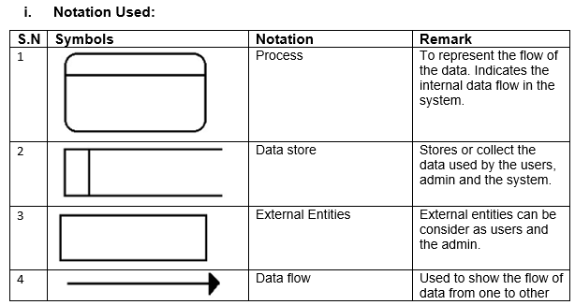

1. **Diagram:**

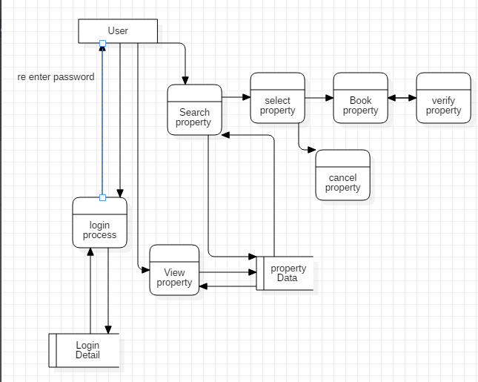

**Figure 1 User DFd**

As data flow diagram represents the flow of the data, process in the system. First diagram shows the users data flow diagram in which the users first login to the system by entering the username and then password. System validate the username and the password if the username and password is correct then system stores the data, if incorrect then ask for re validation. Login data are store in the database. Then users search and view for the property. The searching and viewing process is shown by the process diagram and their database is store in the data base which is represent by data store figure.

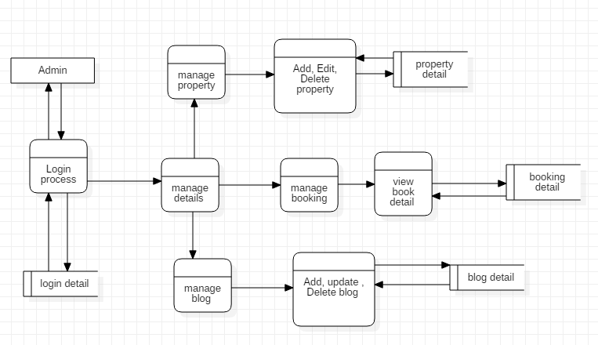

**Figure 2 Admin DFd**

Second figure shows the flow diagram in which the admin login the first login to the system and manage all the users’ details advertisement and property. In this figure admin has manage the property details, users and also manage the booking. Only the admin can add, update and delete the users and property.

**3.1.2 Class Diagram**

In software development class diagram is the structural representation of the system which shows the relation between the attributes, entity. A class diagram in the Unified Modeling Language (UML) is a sort of static structure diagram that describe the structure of a by showing classes, operations (or method), attributes and the connections among object of the system.

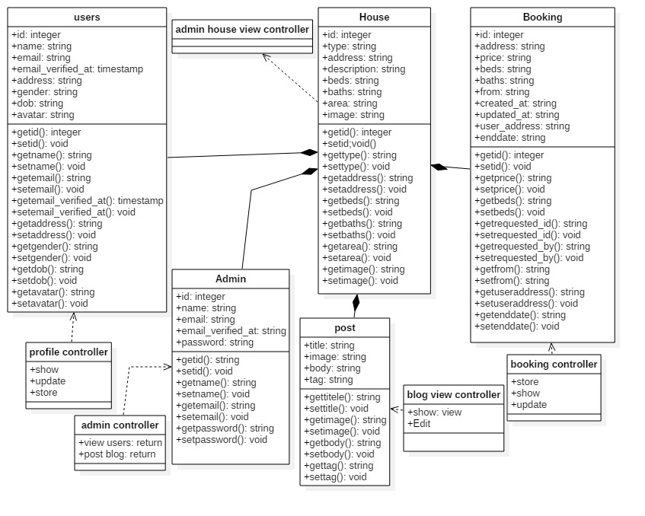

**Figure 3 class diagram for house rental management system**

**3.2 Behavioural Modelling**

**3.2.1 Activity diagram**

1. **Justification**

Activity Diagram is graphical and Behavioural modelling of the software which represent the work flow of the software. It is also the step wise activity or action which helps in describing the whole process of the system.

I have chosen the activity diagram for my system as, it helps to show real/actual work flow in the system. Helps in use case analyzing and describe the users and system action in clear way. Also describe the further action and their occurrence.

1. **Notation Used**

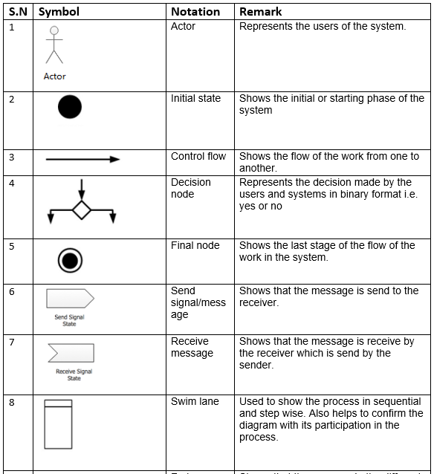

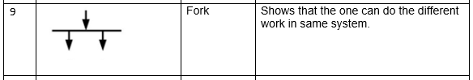

1. **Diagram**

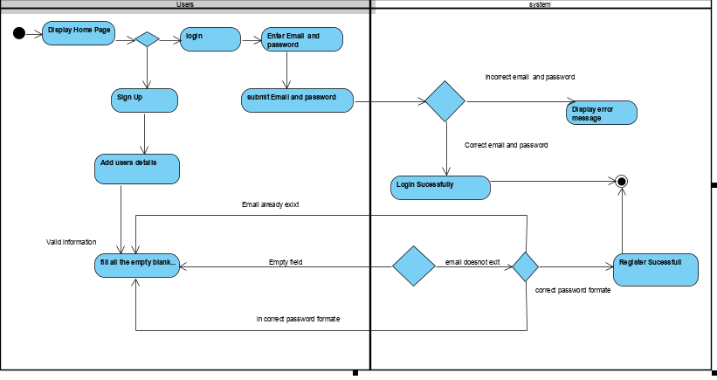

**Figure 4Activity Diagram1**

The above activity diagram shows the flow and activity perform by the users in the system this is the first activity perform by the users in the system. This activity shows that any/all users can use the system but they cannot booked the property. They have to login to the system to use the further system functions. The users have to register and have to enter their valid information. Users have to enter their valid username and password to login to the system. Users cannot control the property detail. They can only add their property details and update the property.

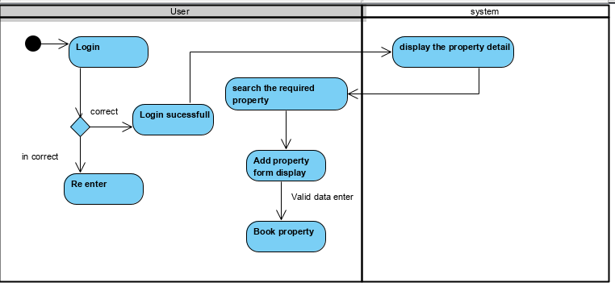

**Figure 5 Activity Diagram2**

The above activity diagram shows the activity between user and the system. Only the register users can use the functions of the system after login. Users can only book the property after login.

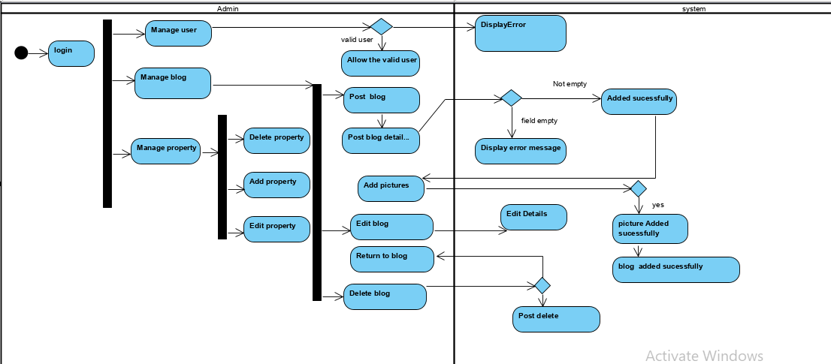

**Figure 6 Activity Diagram3**

Admin also should login to use the system. Admin can manage the users and blog. Admin has control of all the property in which admin can add, update and delete the property. Admin also manage the user booking in which the user can only book the property after admin confirmation.

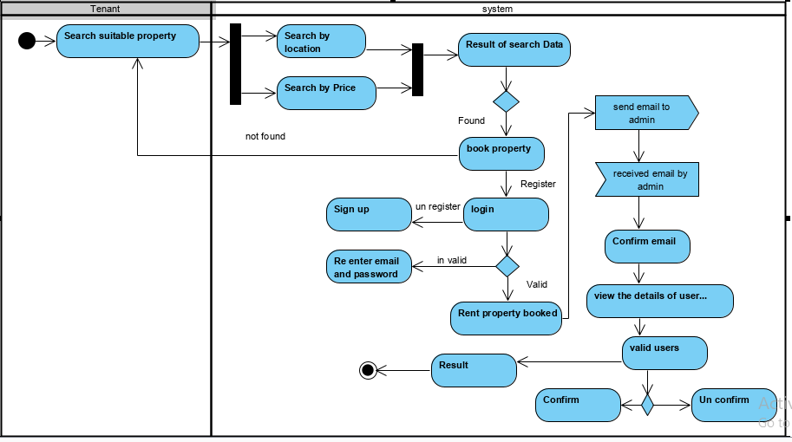

**Figure 7 Activity Diagram4**

Above diagram represent the work flow of the tenant. Tenant can also be consider as the guest users in which they have to sign up first in order to get login to the system. The system validates all the information provided by the users. User Email and password should be unique. The guest users or tenant booked the property after login and confirm the email by the system.

**3.2.2 Sequence Diagram**

1. **Justification**

Sequence diagram is the diagrammatic representation of the system. It shows the object interaction and display as message. Sequence Diagrams are communication diagram that detail how activities are completed. They are time center and they shows the request for the interaction outwardly/visually by utilizing the vertical hub of the diagram to speak to time what messages are sent and when.

The following points represents why the sequence diagram is important to the system.

* + It helps to show the work flow of the system in diagrammatic way.
  + Architectural and logical problem are easily identified.
  + It helps to represent the dynamic view of the system which makes easier to view the system process.

1. **Notation used**

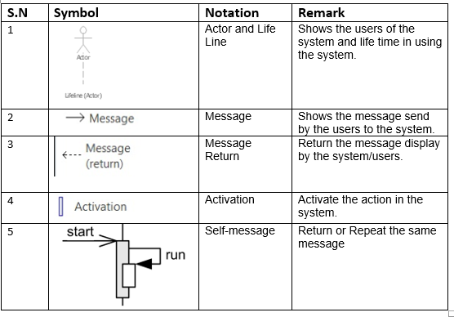

1. **Diagram**

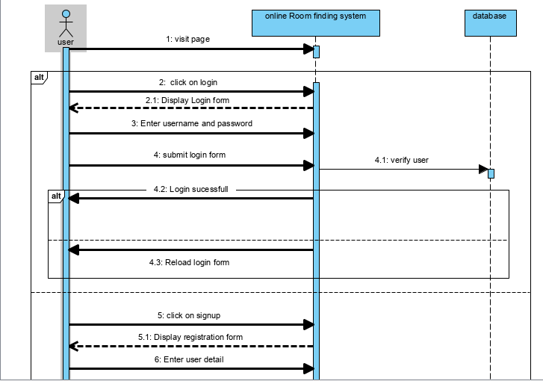

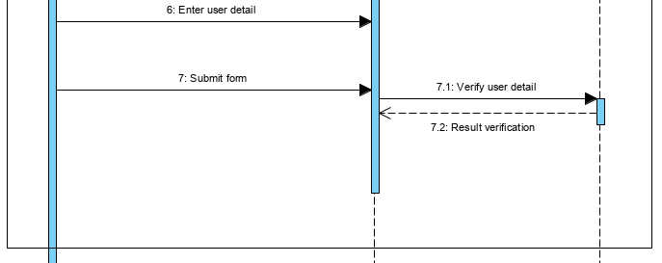

**Figure 8 Sequence Diagram 1**

First figure shows the works flow of the system in which the user login to the system and system verify the username and password which was save in database. If the users is unregister then the user can sign up the form and the register data is store in database.

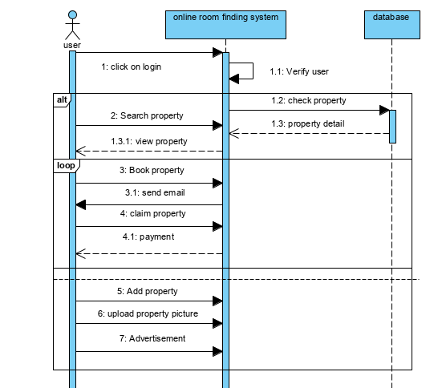

**Figure 9 Sequence diagram2**

This diagram shows that users should login to the system in order to booked property. First the system verify the users as, user data is already record in database. After login user can search, view and booked the property. Property details are already saved in the database. If the property is booked by the users then email is send to the users and email is confirm then property is claim or booked.

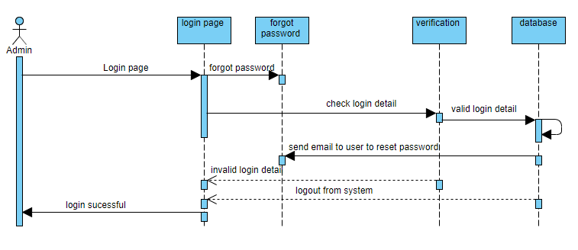

**Figure 10 Sequence diagram 3**

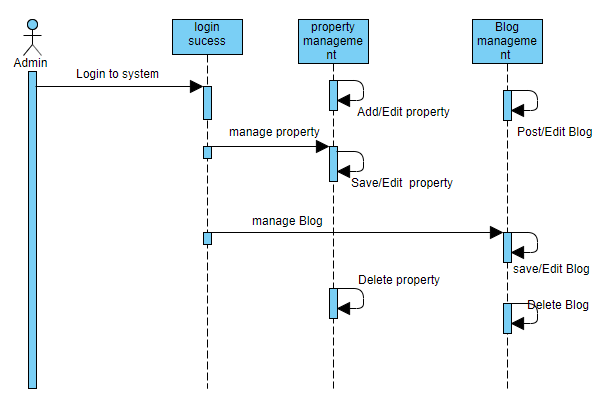

**Figure 10 Sequence diagram 4**

**3.3.1 Data Dictionary**

1. **Justification**

Data dictionary is define as the collection of the data, entity, attributes, name which are been used in database including their property.

Keeps the record of the document which contain database and metadata.

Keeps the record about the objects such as data relationship, data ownership etc.

Metadata of the Er diagram are created bellow in the table.

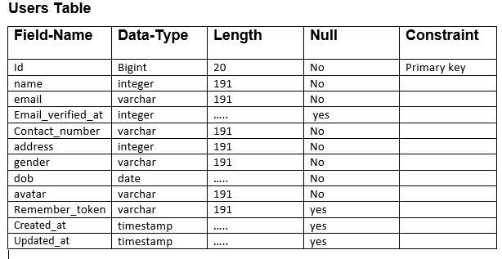

**Admin Table**

|  |  |  |  |  |
| --- | --- | --- | --- | --- |
| **Field-Name** | **Data-Type** | **Length** | **Null** | **Constraint** |
| Id | Bigint | 20 | No | Primary key |
| name | varchar | 191 | No |  |
| email | varchar | 191 | No |  |
| Email_verified_at | timestamp | ….. | No |  |
| password | varchar | 191 | No |  |
| Remember_token | varchar | 191 | No |  |
| Created_at | timestamp | ….. | yes |  |
| Updated_at | timestamp | ….. | yes | Foreign key |

**Booking Table**

|  |  |  |  |  |
| --- | --- | --- | --- | --- |
| **Field-Name** | **Data-Type** | **Length** | **Null** | **Constraint** |
| Id | Bigint | 20 | No | Primary key |
| property | varchar | 191 | No |  |
| address | varchar | 191 | No |  |
| Customer_address | varchar | 191 | No |  |
| price | varchar | 191 | No |  |
| beds | varchar | 191 | No |  |
| baths | varchar | 191 | No |  |
| area | varchar | 191 | No |  |
| Requested_id | integer | 11 | No |  |
| Requested_by | varchar | 191 | No |  |
| from | varchar | 191 | No |  |
| to | varchar | 191 | No |  |
| img | varchar | 191 | No |  |
| status | varchar | 191 | No |  |
| Created_at | timestamp | …….. | yes |  |
| Updated_at | timestamp | ……… | yes |  |
| User_id | Bigint | 20 | No | Foreign key |

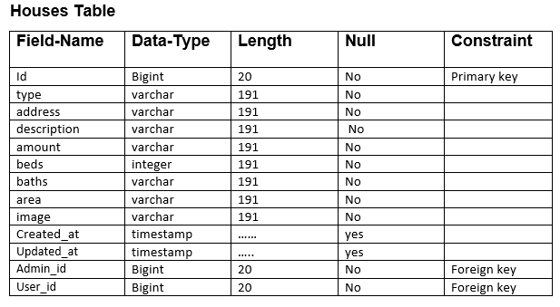

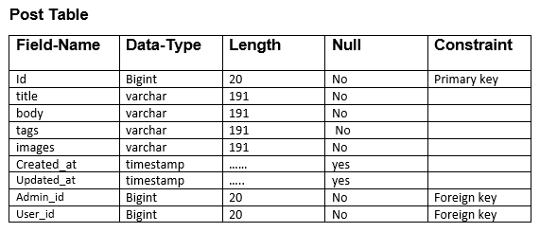

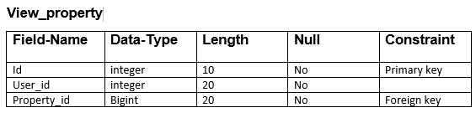

**Password_Reset**

|  |  |  |  |  |
| --- | --- | --- | --- | --- |
| **Field-Name** | **Data-Type** | **Length** | **Null** | **Constraint** |
| email | varchar | 191 | No | Primary key |
| Created_at | timestamp | …… | No |  |
| Admin_id | Bigint | 20 | No | Foreign key |

**3.3.2 Er Diagram**

Er diagram is the entity relationship diagram which shows the relationship between entities like object, conceptual related to each other and people with the system. Er diagram can also be defined as the conceptual diagram. ER diagram are related and identified with Data structure Design (DSDs), which spotlight /focus on the connections of components inside elements rather than connections between substances/entities themselves.

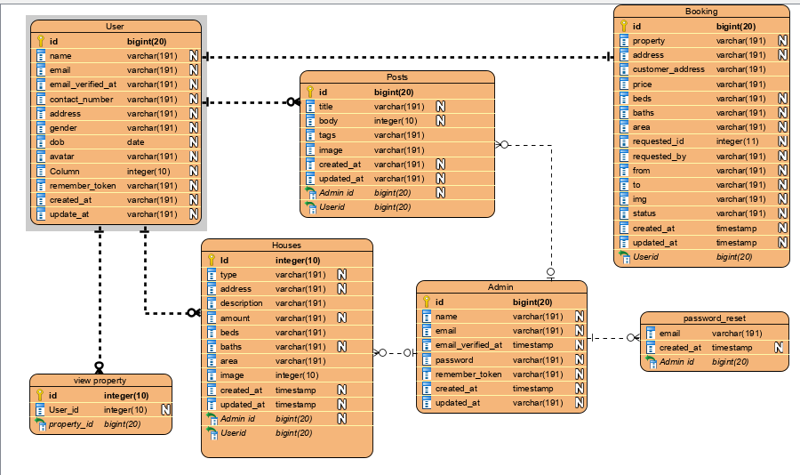

**Figure 11 Er Diagram for house rental management System**

**3.4.1 Prototyping**

Prototyping means the initial phase or stage from which the whole software is developed. A first full-scale and generally practical type of another kind or plan of a development. Also helps to minimize the occurrence of the error and it is easy to update.

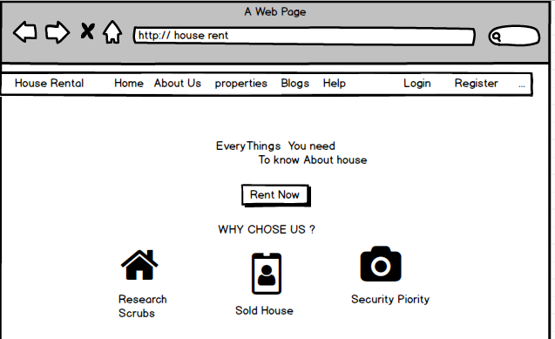

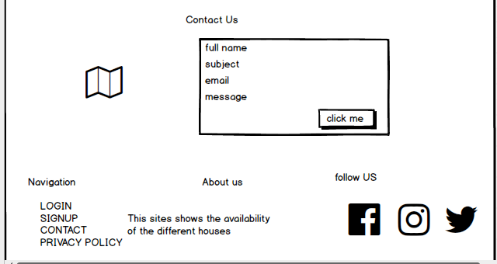

**Figure 12 home page of house Rental management system**

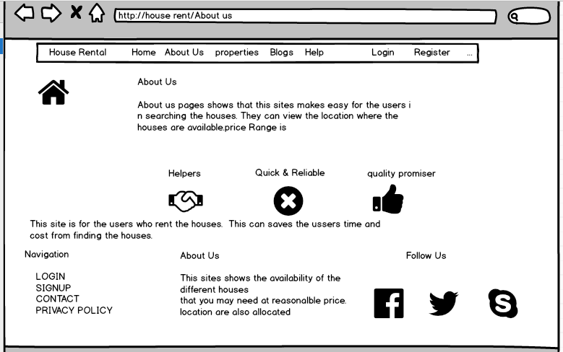

**Figure 13 About Us page of house rental management system**

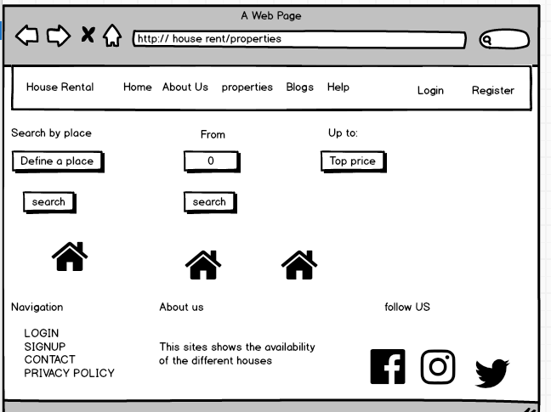

**Figure 14 Property page of house rental management system**

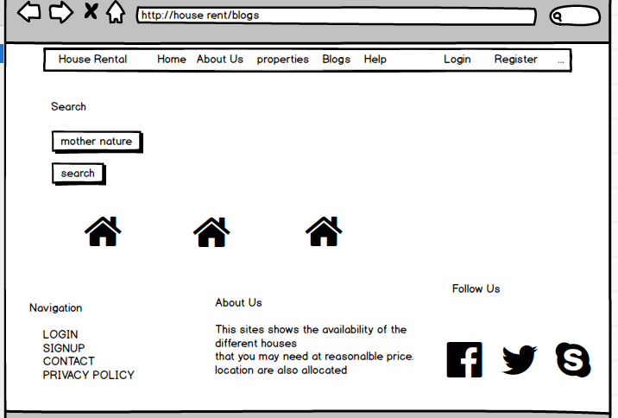

**Figure 15 blog page of house rental management system**

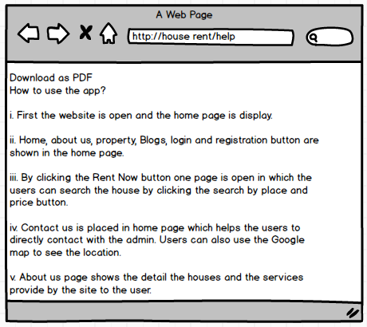

**Figure 16 help page of house rental management system**

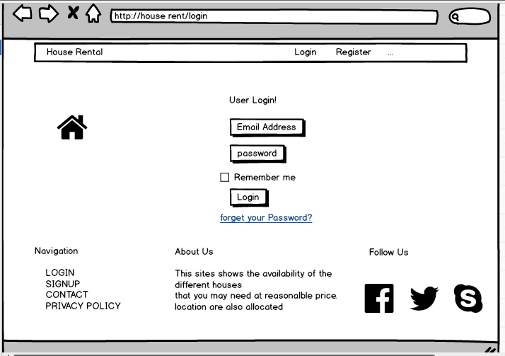

**Figure 17 login page of house rental management system**

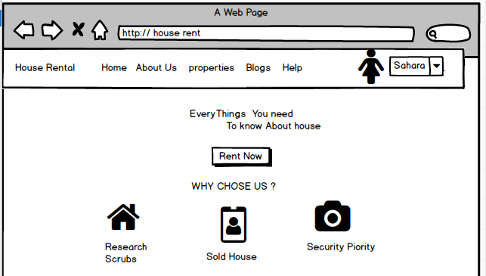

**Figure 18 login page of user Sahara**

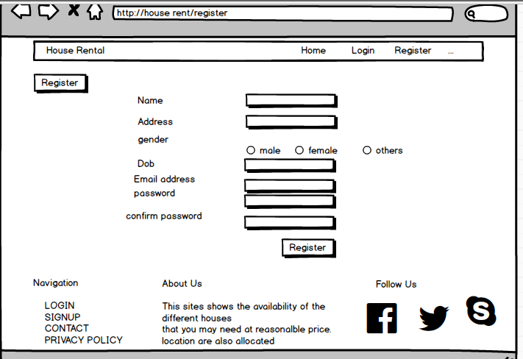

**Figure 19 register page of house rental management system**

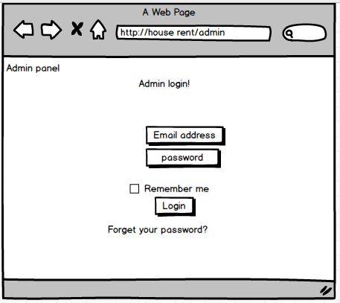

**Figure 20 login page of Admin**

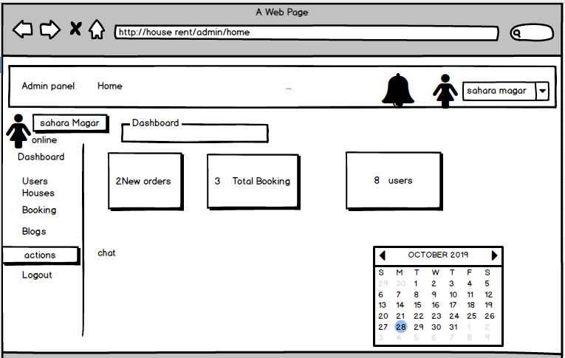

**Figure 21 Admin dashboard**

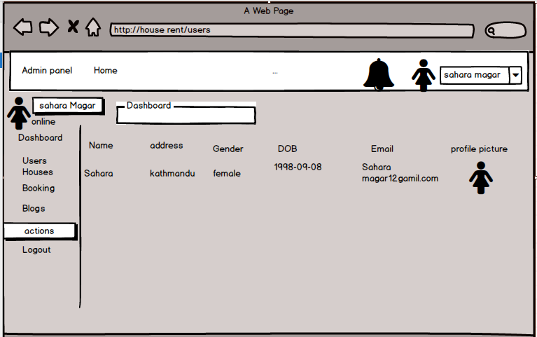

**Figure 22 user who have login**

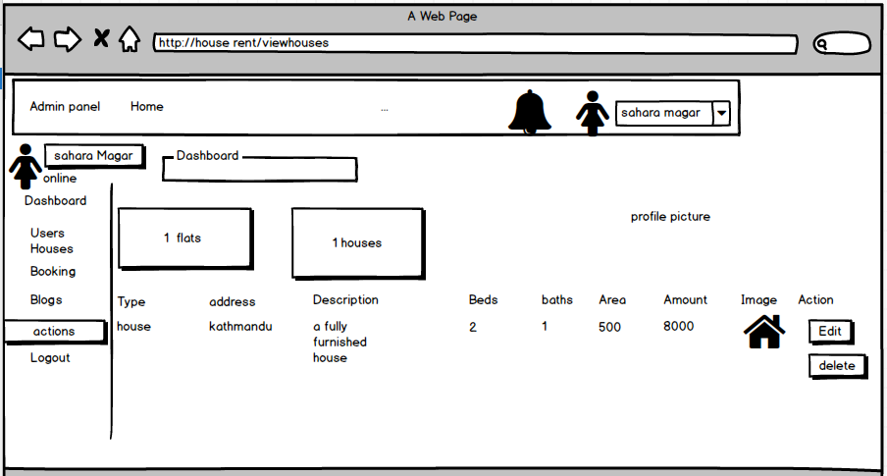

**Figure 23 list of the houses**

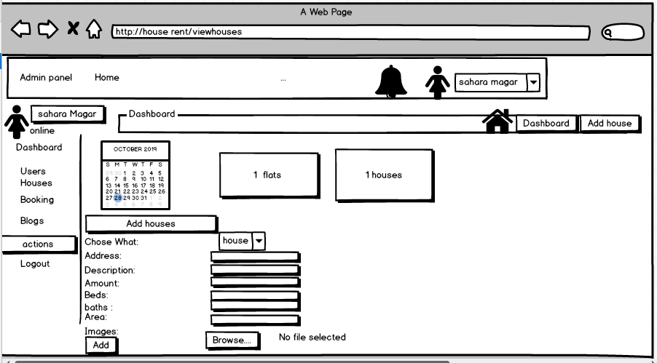

**Figure 24 form for adding houses**

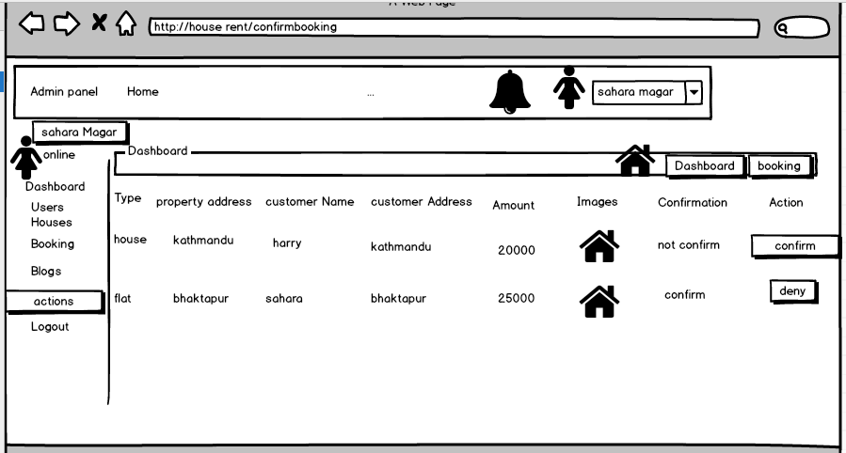

**Figure 25 Users who have booked the houses**

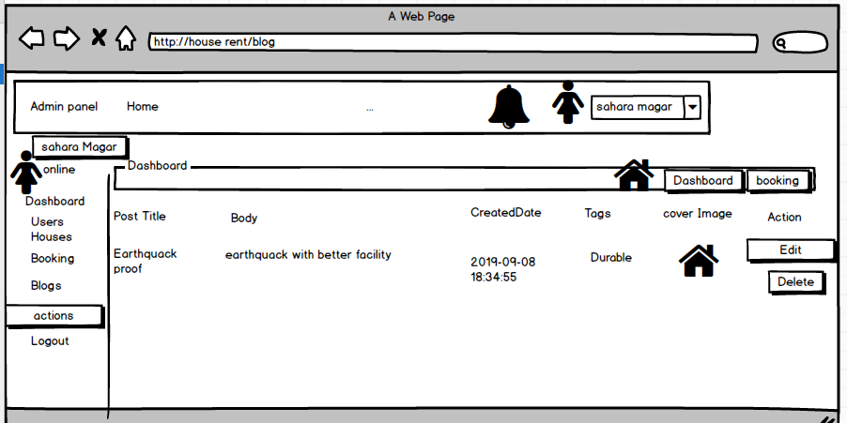

**Figure 26 list of blog used**

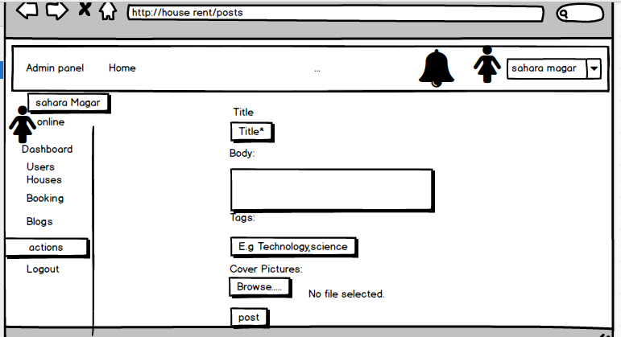

**Figure 27 form for posting blog**